Experiment No: 2 Exporatory Data Analysis(import and export files)

Aim:
To import and export different types of files using python.

Algorithm:
- Start the program.
- Import the required library (pandas).
- Specify the path or name of the CSV file.
- Read the CSV file using the read_csv() function.
- Store the imported data in a DataFrame (df).
- Display the first few records using head().
- Check the dataset information using info().
- Display the statistical summary using describe().
- Verify that the dataset has been imported successfully.
- Stop the program.

Program:
Importing csv files:
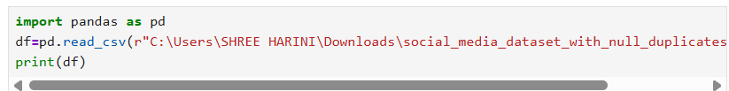
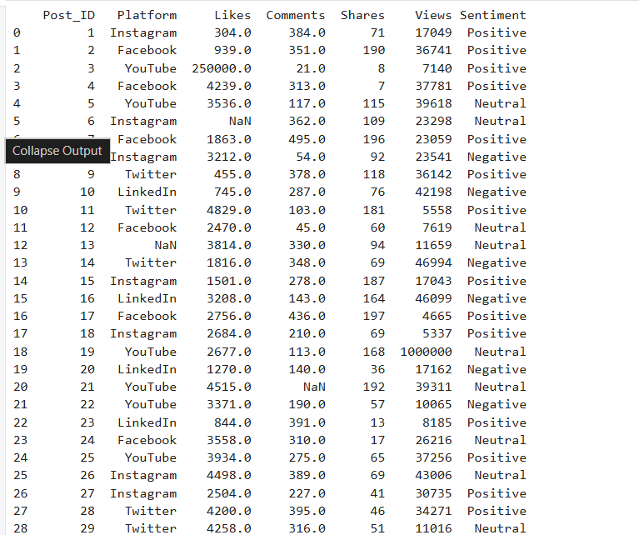

. 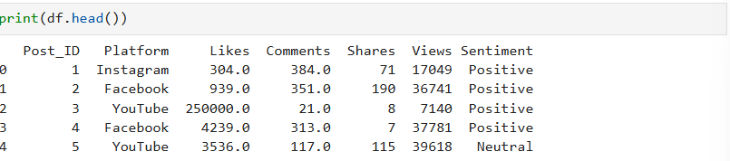

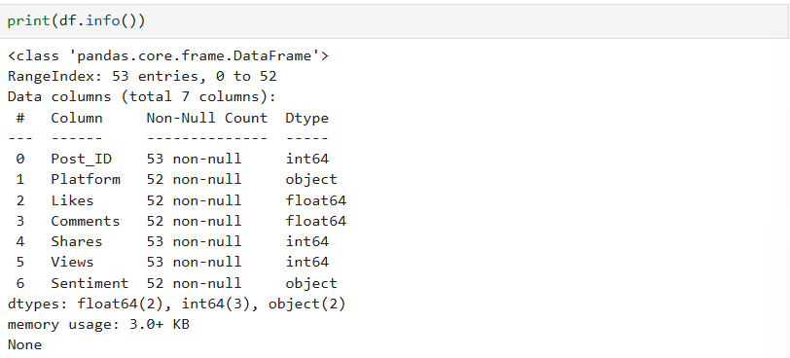

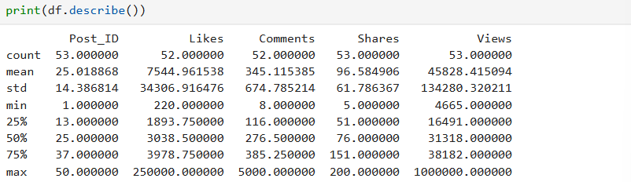

Exporting csv file:
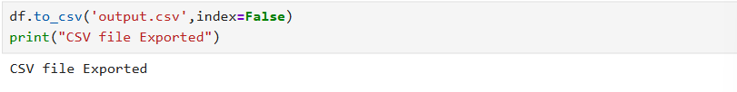

Visualization:
